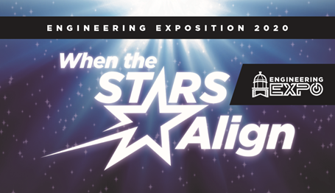

Nanorover Competition

March 7th, 2020
J.B. Speed School of Engineering
Belknap Academic Building

Elementary School Division: K - 5th
Middle School Division: 6th - 8th
High School Division: 9th - 12th

Contact Information:
Luke Malone
Engineering Exposition Coordinator
SSSC Executive Vice President
evp@speedcouncil.org
Caty Battjes
Competition Coordinator
caty.battjes@gmail.com
TO PARTICIPATE IN THE NANOROVER CONTEST:

- Start a team or participate individually
- Register for the competition
- Go to speedcouncil.org
- Hover over the “E-Days” tab to see the drop down
- Click on the “E-Expo” tab
- Hit the “Register” button
- Complete the google form for a “K-12 attendee”
- Complete the registration for your team, noting the amount of people participating per submission, the primary contact for each submission, and the name of the submission.
- Design and build a rover
- Guidelines for the competition are below.
- Compete
- E-Expo will be held on March 7, 2020 at the J.B. Speed School of Engineering.
- Teams/individuals will be notified of their assigned judging time closer to the event.

Design an astronaut’s rover that fits within the constraints listed below.

The rover should be designed to be efficient and able to easily move across different types of terrain.

Success Criteria

-(10 points) The nanorover should be able to travel across its set distance and not be flipped over. If the rover is flipped over, it should be able to recover and continue driving.
-(10 points) The rover will be required to move across at least 5 feet of terrain. The course will be provided on the day of the event.
-Different terrains and aspects of the course will include:
    - Flat surface
    - Rocky terrain
    - Angled up 40 degrees
    - Angled down 40 degrees
    - Wavy/able to make turns
-(10 points) The rover must be able to move on its own, with no contestant pushing it along the course.

Constraints
-(5 points) The rover must be constructed using everyday objects, such as but not limited to:
    - Cardboard
    - Tin foil
    - Cans
    - Paper
    - Extra points may be awarded as denser/more rigid materials are successfully utilized.
-(5 points) A motor must be utilized in the design of the rover. The motor will be the source of the rover’s motion, and participants are encouraged to design their own. The more creative design, the better!
-(10 points) The rover must feature between 3 and 6 functional wheels. A wheel that does not function will not be included in the final count.
- (10 points) The rover must have a total height between 3” and 6”, and a length and Width between 5” and 8”.

Justification (Poster Presentation)
-Defend your rover’s design
    - (10 points) Explain why the materials used were chosen and what advantage they provide.
    - (10 points) What steps were taken in developing your design?
    - (5 points) Why should an astronaut use your design?
    - (5 points) What are the advantages of the design of the rover that set it apart from others? Why is the design important for the future of space travel?
  - Make a poster board outlining your design choices
    - (10 points) Highlight the different parts on your rover and explain each functionality.
    - Be sure to provide pictures and plenty of creativity with the poster. Contestants will be asked to tell the judges about the rover using the above criteria.

